**Q1 Extract data except for the States Wisconsin and Pennsylvania. Determine what is the row count for the Orders Table using Tableau’s auto generated field?**

✔️ 9297  
  
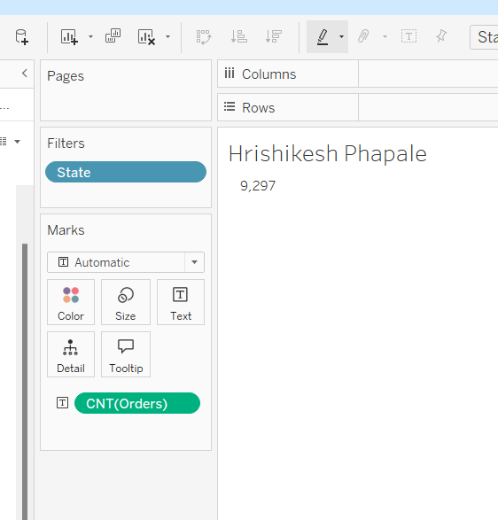

Q2 Using the extract created from Question1, build a Pie Chart to calculate the percent of Total Quantity for the Central and South Regions in the year 2018 and 2019 for Ship Mode “First Class” and “Second Class”?Note: No decimals in the final view.

✔️ 22% Central

✔️ 17% South

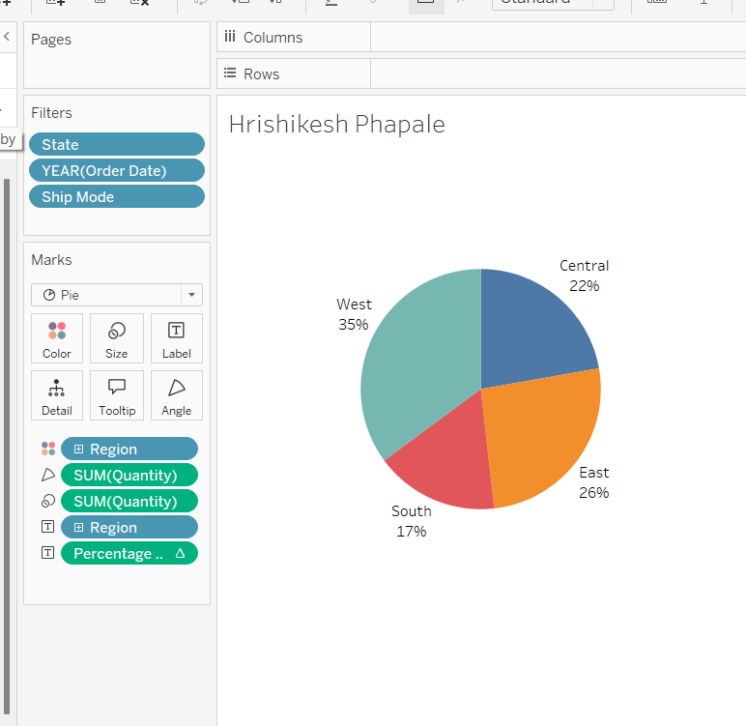

Q3 Duplicate the Extract and make a live connection. Showing multiple bar charts across the 4 years. Determine which Sub-Category has the highest Sales for 2019 and 2020, along with the amount.

✔️ Chairs $71,735 -2019

✔️ Chairs $83,919 -2020

2019 Sorted

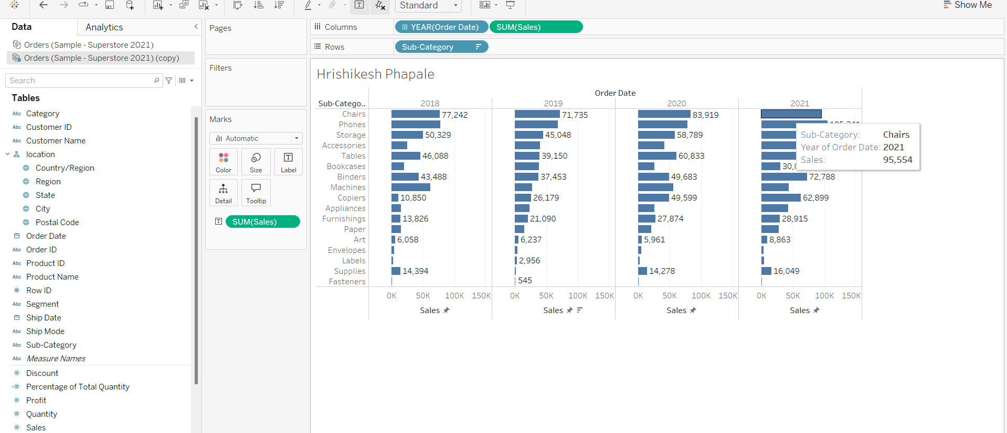

2020 Sorted

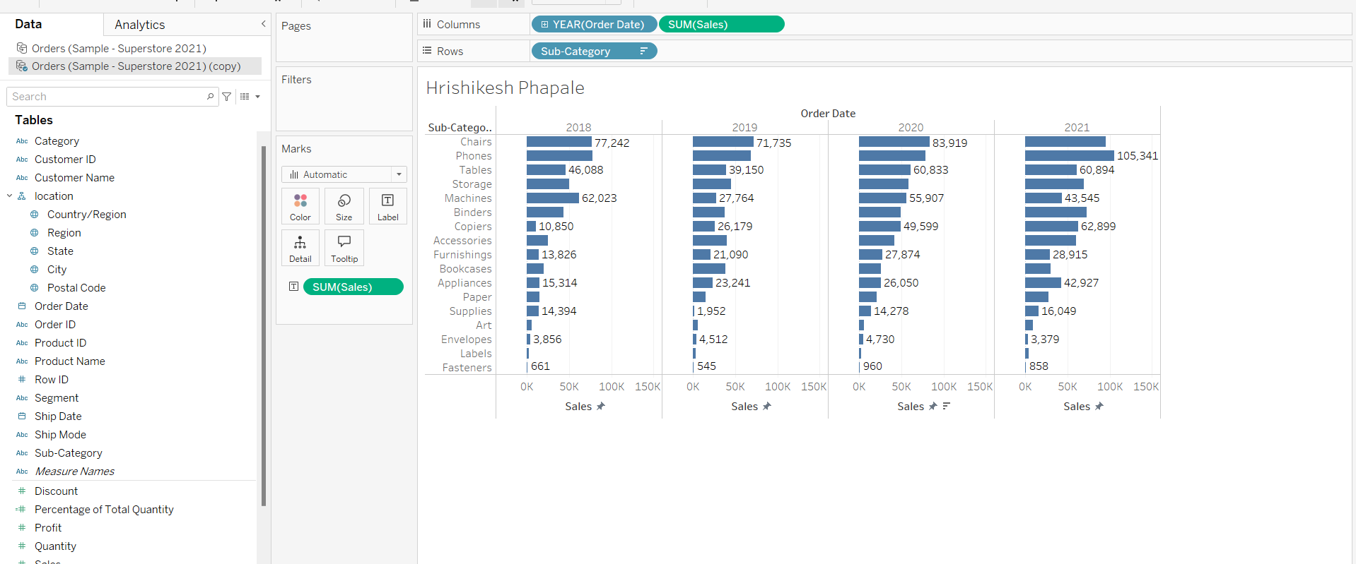

Q4 For the Top 10 States by Sales, determine the total sales for the Sub-Category “Copier” using a Column Chart? [Sets needed]

Note: Labels should be displayed in $ with units in Thousands(K).

✔️ $94.68 K

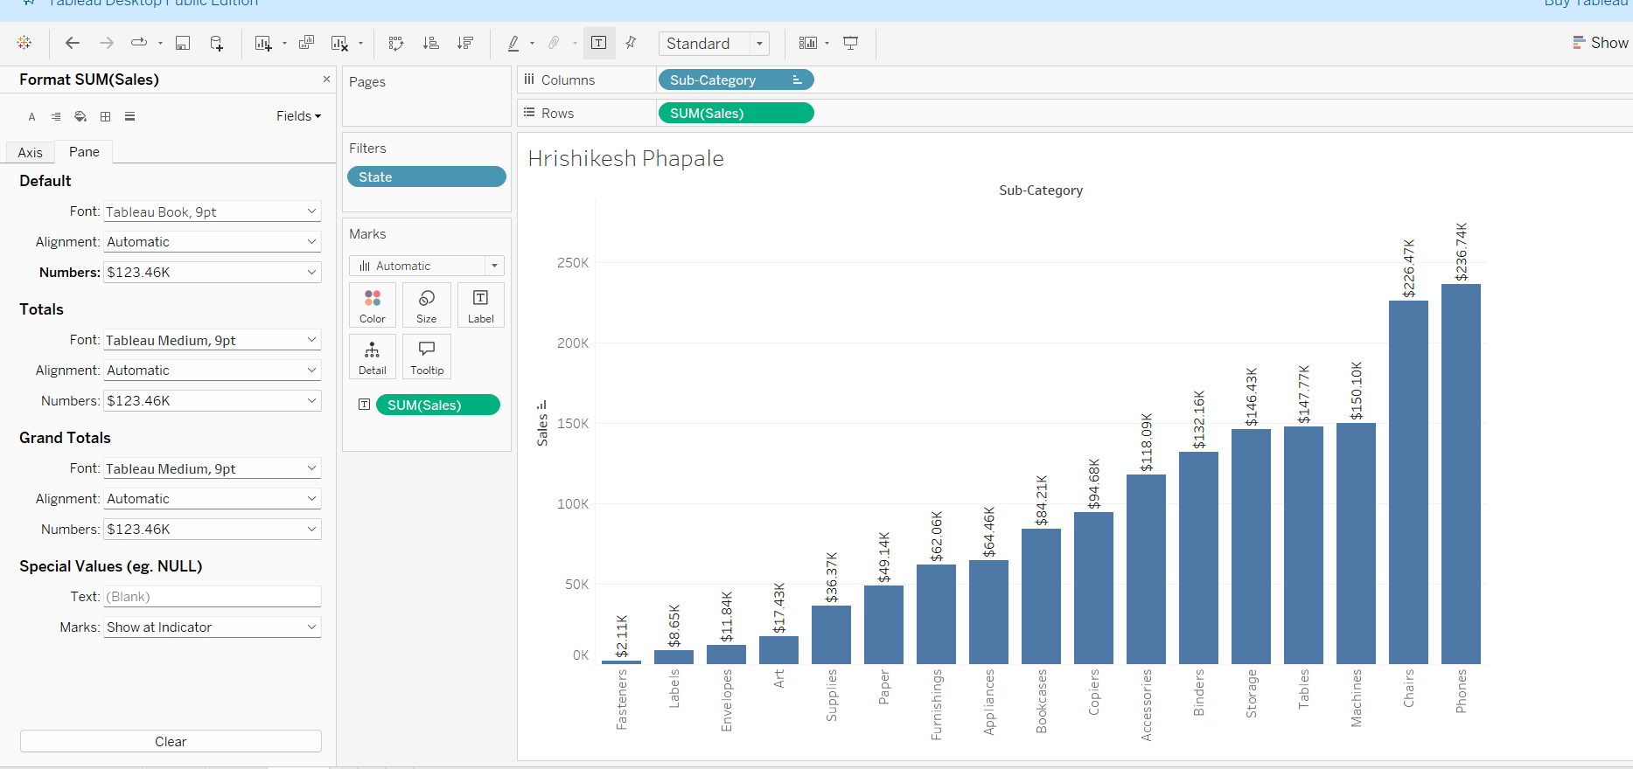

Q5 Build a cross-tab for Sub-Category showing multiple measures like Discount, Quantity, and Sales. Highlight those Sub-categories having discount greater than 100 with a different color in the table. Format the Sales numbers in $ and display units in Thousands (K).

Note: Also mention your Full Name in the Sheet title.

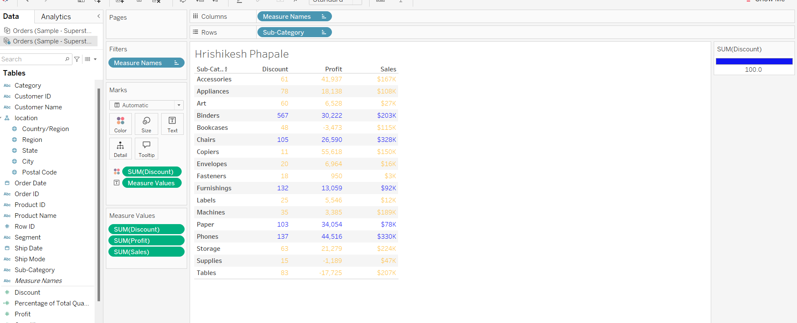

Q6 Build a Continuous Line Chart with Order Date showing running total sum of Profit along the end of 2021. Find out and mark the Total profit in $, Display units in K, and up to 2 decimals for March 2021.

Also, show only the label showing Month-Year and the running sum of profit for that data point.

Note: Also mention your Full Name in the Sheet title.

Expected result:

✔️ $216.46K

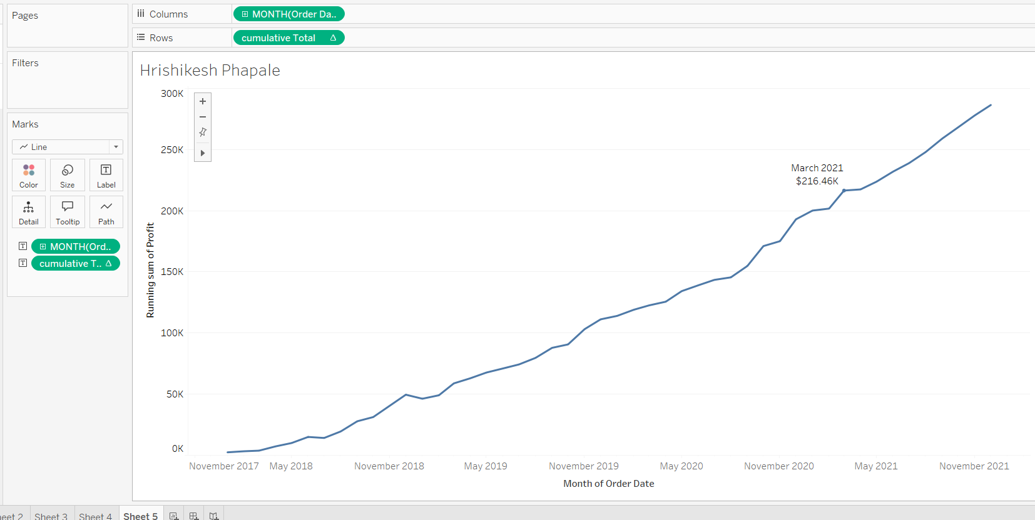

Q7 Build a Stacked Column Chart showing percent of Total Sales broken down by Ship Modes per region. What is the percent of Total Sales in the East region when computed using region?

Note: Also mention your Full Name in the Sheet title.

✔️ 33.75%

